Roll No: 241901064
Name: M S Nanthana Shree
TCP CLIENT SERVER USING SCOKET PROGRAMMING IN PYTHON
Aim:
To implement TCP client- server communication using socket programming in python.
Algorithm:
Server
1.Create a socket using socket.socket().
2.Bind the socket to an IP and post using bind().
3.Listen for client connection using accept().
4.Accept client connection using accept().
5.Receive data using recv().
6.Send response using send().
7.Close connection.
Client
1.Create a socket using socket.socket().
2.Connect to server using connect().
3.Send data using send().
4.Receive response using recv().
5.Close connection.
PROGRAM:
SERVER:
import socket
sockfd=socket.socket(socket.AF_INET, socket.SOCK_STREAM) print('Socket Created')
sockfd.bind(('localhost',55555))

sockfd.listen(3)
print('Waiting for connections')
while True:
clientfd,addr=sockfd.accept()
receivedMsg=clientfd.recv(1024).decode()
print("Connected with ",addr)
print("Message Received from Client: ",receivedMsg) clientfd.send(bytes(receivedMsg,'utf-8'))
print("Message reply sent to Client!")
print("Do you want to continue(type y or n):")
choice=input()
if choice=='n':
CLIENT:
import socket
clientfd=socket.socket(socket.AF_INET, socket.SOCK_STREAM) clientfd.connect(('localhost',55555))
name=input("Enter your message:")
clientfd.send(bytes(name,'utf-8'))
print("Message Received from Server: ",clientfd.recv(1024).decode())

OUTPUT:
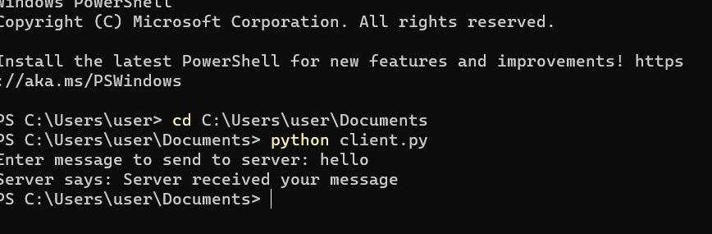
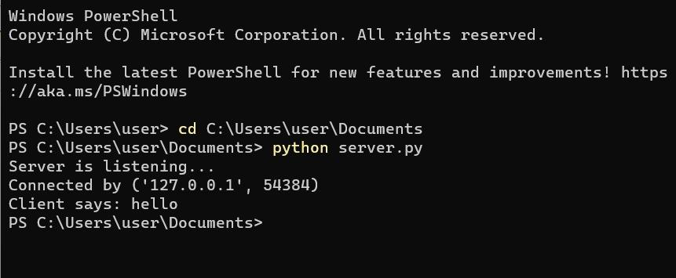
Result:
Thus TCP server-client communication was successfully implemented using
python.

